UNIT 3 – REVISION

- Prevedi besede. Ne pozabi na člen A/AN.

medvedek – _______________________ letalo – _______________________________
zmaj – _____________________________ računalnik - ___________________________
obroč – ___________________________ kocke - _______________________________
balon – ___________________________ kolo - _________________________________
žoga – ____________________________ družabna igra - ________________________

- Zapiši števila z besedo.
13 – ______________________________ 11 - _____________________________
16 – ______________________________ 15 - _____________________________
18 – ______________________________ 12 - _____________________________
20 - ______________________________ 19 - _____________________________

- Zapiši člen A ali AN.
____ egg _____ doll ____ yellow bear _____ old computer
____ yo-yo _____ elephant _____ long train ____ umbrella

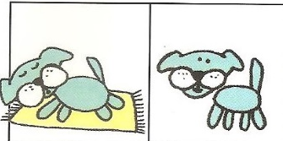
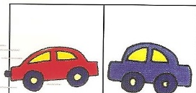
- Napiši nasprotja.

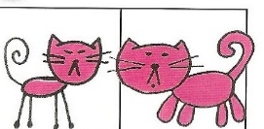
a fast car – a slow car _____________________
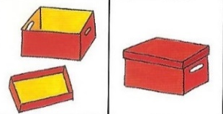
_______________________ ______________________
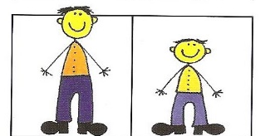
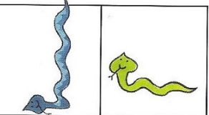
_____________________ ______________________

- Prevedi povedi.
Imam rdeč avto. ________________________________________________
Nimam zelenega zmaja. ____________________________________________
Imam dolg vlak. _____________________________________________________
Nimam starega medvedka. ___________________________________________
Imam tri žoge. _______________________________________________________
Nimam debelega robota. ___________________________________________


- Dopolni besedilo z besedami iz okvirja.
grey name a robot friendly family parrot grey big

My _________________is Peter. I'm nine years old. I have got a lot of toys. My favourite toy is _______________________. It is ______________, black, red and blue. It is a _______________toy, 1 m tall. I have one sister. She is ____________________. We live in a big _____________. We have got a pet, a _________________. We are a happy ____________________.

- Na kratko odgovori na vprašanja.
How old is Peter? _____________________
What is Peter's favourite toy? __________________
Is the robot small? ______________________
Has Peter got a sister? ____________________
What animal has Peter got? _________________
Is Peter happy? _______________________

