- Preveri in popravi domačo nalogo.
- Zapis snovi v zvezke: ANIMAL BODY PARTS.
- DZ str. 47, 48, 50 – pomagajo naj si z zvezkom, rešitve so spodaj.
- Naloga DZ str. 53/a – hitrejši jo lahko naredijo že med poukom.

HOMEWORK
Prevedi povedi.
1. Mačka je udomačena. A cat is tame.
2. Želva je tiha. A turtle is quiet.
3. Kokoš je glasna. A chicken is loud.
4. Lev je nevaren. A lion is dangerous.
5. Pujs je umazan. A pig is dirty.
6. Gos ni močna. A goose isn't strong.
7. Petelin ni dolgočasen. A cockrel/a rooster isn't boring.
8. Puran ni sramežljiv. A turkey isn't shy.
9. Lastovka ni lena. A swallow isn't lazy.
10. Raca ni delovna. A duck isn't hardworking.

ANIMAL BODY PARTS

a body- telo whiskers - brki
ears – ušesa paws - tačke
eyes - oči claws - kremplji
wings – krila a fin – plavut
a tail – rep a shell - oklep
a beak – kljun a trunk - rilec
horns – rogovi a snout - smrček
feathers - peresa hoofs - kopita
a mane - griva gills - škrge
scales – luske a tusk - okel

REŠITVE:
STR. 47/10
FU-NNY LA-ZY FRIEND-LY WE-AK BO-RING STRO-NG

STR 47/11.
Across - vodoravno
3 – BIG
4 -FRIENDY
6 – TAME
8 – WEAK

Down - navpično
1 – BLACK
2 – LAZY
3 – BRAVE
5 – HAPPY
7 – FUNNY
8 – FAST

STR. 48 - vsak reši po svoje

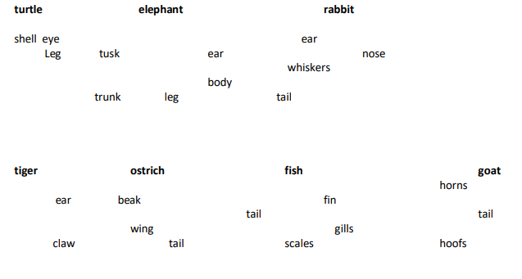
STR. 50/1
STR. 50/16.
shell A | horn A | hoofs A | head B | eyes B
beak A | wing A | feathers A | teeth B | nose B
scales A | fin A | gills A | snout A | cheek B
whiskers B | claw A | paw A | mane A | hip B
tusk A | feet B | trunk A | tail A | neck B
back B | heart B | hair B | knee B | elbow B

STR. 50/17.

1-3-2

