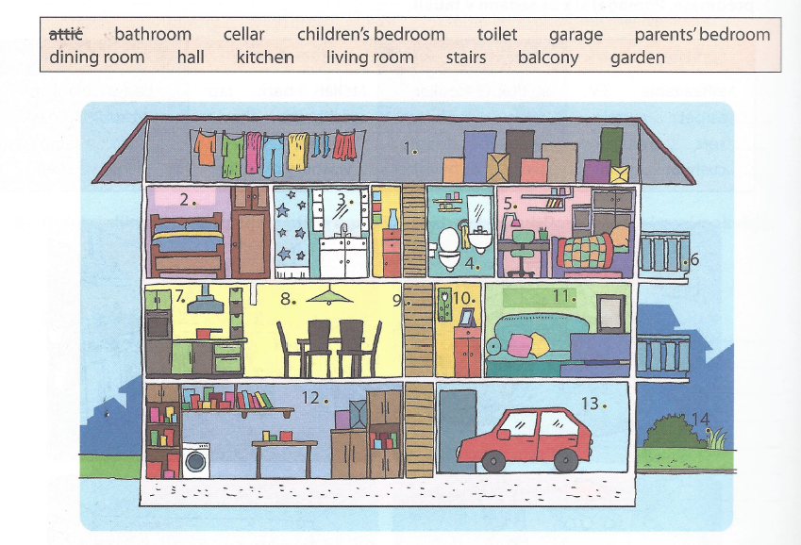
MY HOME
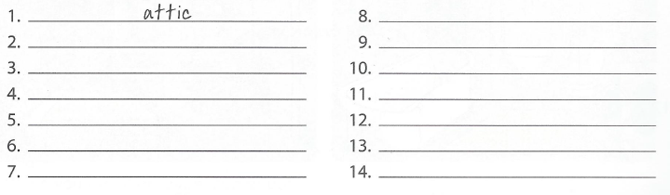
Complete the text. Dopolni besedilo.
Alicia usually sits on the bed in her _____________. She listens to music, reads magazines or studies. Around 7 o'clock, her mum makes dinner in the ___________. Her brother Stan is usually in the ____________________. He takes a shower. The TV is in the ________________, but they rarely watch it. Dad always comes home for dinner. He parks his car in the ____ ___________. He hangs the jacket in the __________. He sometimes goes to the ______________ to get some wine. Then they eat dinner in the _______________________. They sometimes hear mice running in the _____________.

