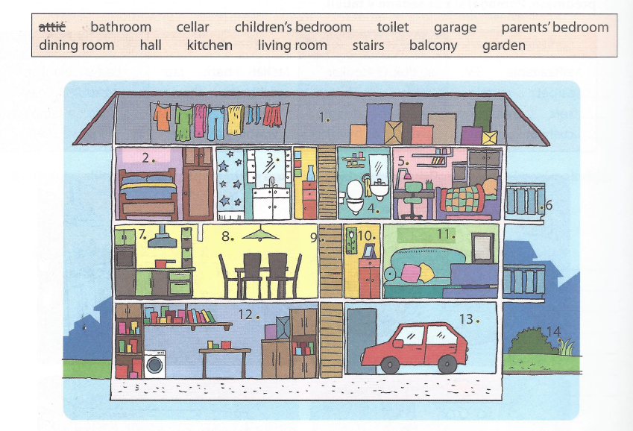
MY HOME

2. parents' bedroom 8. dining room
3. bathroom 9. stairs
4. toilet 10. hall
5. children's bedroom 11. living room
6. balcony 12. cellar
7. kitchen 13. garage
14. garden

Complete the text. Dopolni besedilo.
Alicia usually sits on the bed in her _bedroom_. She listens to music, reads magazines or studies. Around 7 o'clock, her mum makes dinner in the __kitchen_. Her brother Stan is usually in the _bathroom_. He takes a shower. The TV is in the _living room_, but they rarely watch it. Dad always comes home for dinner. He parks his car in the _garage_. He hangs the jacket in the __hall_. He sometimes goes to the _cellar__ to get some wine. Then they eat dinner in the __dining room_. They sometimes hear mice running in the __cellar/attic_.

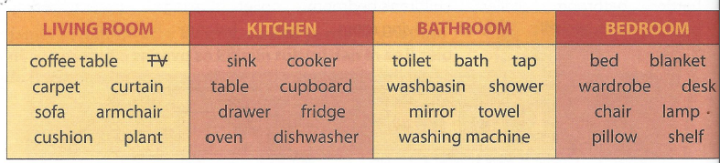

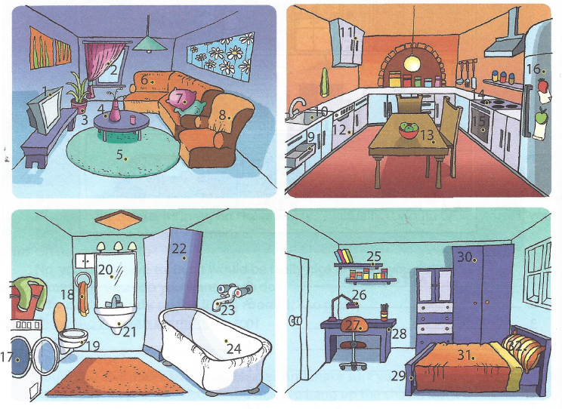
1. TV 9. DRAWER 17. WASHING MACHINE 25. SHELF
2. CURTAIN 10. SINK 18. TOWEL 26. LAMP
3. PLANT 11. CUPBOARD 19. TOILET 27. CHAIR
4. COFFEE TABLE 12. DISHWASHER 20. MIRROR 28. DESK
5. CARPET 13. TABLE 21. WASHBASIN 29. BED
6. SOFA 14. COOKER 22. SHOWER 30. WARDROBE
7. CUSHION 15. OVEN 23. TAP 31. BLANKET
8. ARMCHAIR 16. FRIDGE 24. BATH 32. PILLOW

